SERVERLESS P2P FILE SHARING
WebApp — Interview Preparation Guide
React.js · Node.js · WebRTC · Socket.io
On-Campus Fresher SDE Interview — A to Z
Covers: Introduction · Project Deep Dive · WebRTC Theory & Code · System Design · API · Socket.io · Non-Technical · STAR Answers · Hardest Bugs · Challenges · Learnings · Future Scope · Diagrams

TABLE OF CONTENTS
SECTION 1 — Project Introduction & Overview
SECTION 2 — WebRTC Deep Dive — Theory & Code
SECTION 3 — Socket.io & Signaling Server
SECTION 4 — File Chunking, Web Workers & Live Stats
SECTION 5 — Encrypted P2P Chat
SECTION 6 — API Reference — REST & Socket.io Events
SECTION 7 — System Design & Architecture
SECTION 8 — Behavioural & Non-Technical Q&A
SECTION 9 — Common Technical Interview Questions
SECTION 10 — Edge Cases & Corner Cases
SECTION 11 — Quick Reference Cheat Sheet

SECTION 1: Project Introduction & Overview

1.1 The Elevator Pitch (30 seconds)
Q: Tell me about your project.
Answer:
I built a serverless peer-to-peer file sharing web app — like a lightweight version of WeTransfer or ShareDrop, but with no cloud storage at all. Files travel directly from one browser to another, encrypted end-to-end, using WebRTC DataChannels. A lightweight Node.js + Socket.io signaling server only brokers the initial handshake; after that it's completely hands-off. I also built a real-time encrypted chat on the same P2P channel. Users connect via a 1-click 10-digit token — share the code, click connect, done. Files of any size transfer in the browser thanks to 16 KB chunking offloaded to Web Workers so the UI never freezes.

1.2 Project Motivation & Problem Statement
Q: Why did you build this? What problem does it solve?
Answer:
Situation: Most file-sharing tools (Google Drive, WeTransfer) route files through a central server. This creates privacy concerns, bandwidth costs, and size limits.
Task: I wanted to build a system where files NEVER leave the sender's browser except to go directly to the recipient — no server ever sees the file bytes.
Action: Used WebRTC DataChannels which create a direct encrypted tunnel between browsers. Socket.io handles only the ~500 bytes of signaling data needed to set up the tunnel. Implemented chunking + Web Workers for multi-GB support.
Result: A working app where two users can connect with a 10-digit token and transfer files of any size at full local-network speed (~50 MB/s on LAN), with zero server storage costs.

1.3 Tech Stack & Rationale
Technology | Role & Why Chosen
React.js | Frontend SPA — component model is ideal for real-time state (progress bars, active peers, chat). Hooks (useState, useRef, useEffect) manage WebRTC lifecycle.
Node.js + Express | Signaling server backend — lightweight, event-driven, perfect for high-concurrency WebSocket connections. Also serves REST endpoints for room management.
Socket.io | Signaling layer over WebSocket. Provides rooms, event namespacing, auto-reconnection, and fallback to long-polling. Used ONLY for signaling (SDP + ICE), never for file data.
WebRTC DataChannel | The P2P data pipe. DTLS-SRTP encrypted by default. Supports binary (ArrayBuffer) transfer. Two DataChannels: one for files, one for chat.
Web Workers | Off-main-thread file chunking loop. Prevents UI freezing during multi-GB transfers. postMessage API for progress updates back to React.
STUN Server | Public server (Google's stun.l.google.com) that tells each peer its public IP/port for NAT traversal. No TURN server needed for most connections.

SECTION 2: WebRTC — Complete Technical Deep Dive

2.1 What is WebRTC? (Non-Technical)
Q: Explain WebRTC to a non-technical person.
Answer:
Normally when you send a file online, it goes: Your computer → Server → Their computer. WebRTC is like giving your browser a direct phone line to another browser. Once the call is connected, data flows straight between the two — the server is no longer involved. It's like switching from mailing a letter through a post office to handing it directly to someone.

2.2 WebRTC Technical Definition
Q: What is WebRTC and what are its core components?
Answer:
WebRTC (Web Real-Time Communication) is a browser API + set of protocols that enables direct peer-to-peer communication for audio, video, and arbitrary data between browsers without plugins. Core components:
- RTCPeerConnection: The main object representing the P2P connection. Handles ICE, DTLS, and SRTP internally.
- RTCDataChannel: A bidirectional byte channel over the P2P connection. Supports binary (ArrayBuffer) and text. Can be ordered/reliable (TCP-like) or unordered/unreliable (UDP-like).
- ICE (Interactive Connectivity Establishment): Protocol for finding the best network path between two peers — direct, via STUN, or via TURN.
- SDP (Session Description Protocol): A text format describing connection parameters — codecs, IP addresses, port numbers, capabilities.
- DTLS (Datagram TLS): Provides encryption for DataChannel. All WebRTC data is encrypted by default — mandatory, not optional.

2.3 The Signaling Problem
Q: WebRTC is P2P — then why do you need a server at all?
Answer:
WebRTC handles data transfer P2P, but the two peers first need to find each other and agree on connection parameters. They can't do this directly because they don't know each other's IP addresses yet. This bootstrapping is called signaling.
Signaling involves exchanging two things:
- SDP Offers & Answers: Peer A creates an 'offer' (its capabilities and network info). Peer B creates an 'answer'. These are ~2KB JSON blobs exchanged via the signaling server.
- ICE Candidates: A list of possible network addresses (local IP, public IP via STUN, TURN relay). Trickled to the other peer as they're discovered.
Key insight: The signaling server sees ZERO file bytes. It relays only ~4–8 KB of metadata to set up the connection, then steps aside. My Socket.io server is purely a signaling relay.

2.4 Architecture Diagram
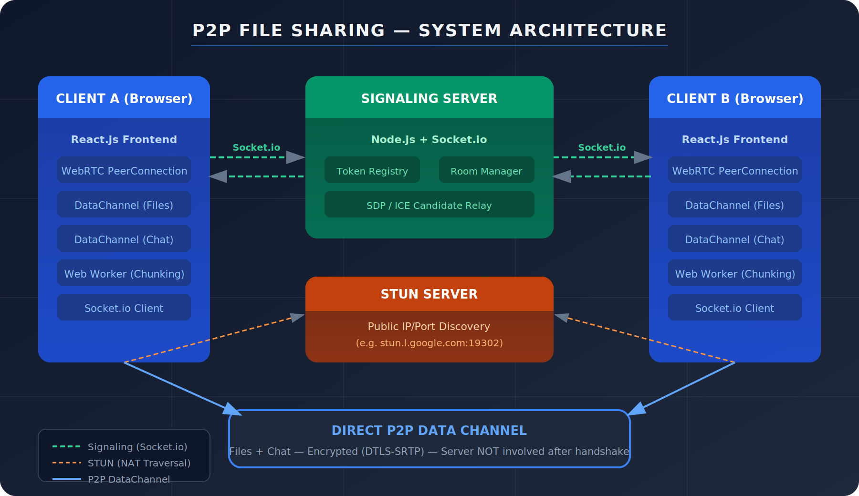
Figure 1: High-Level System Architecture — P2P DataChannel after signaling handshake

2.5 WebRTC Handshake Flow Diagram
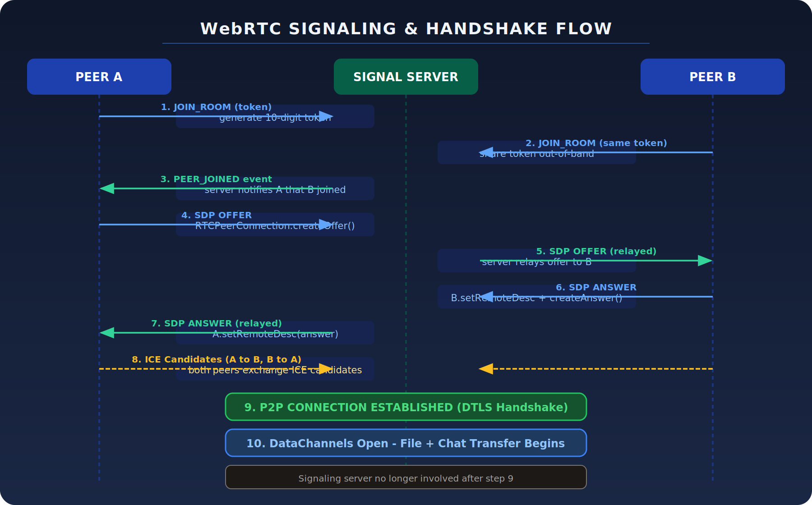
Figure 2: WebRTC Signaling & Handshake — 10-step connection establishment

2.6 RTCPeerConnection — Core Code
Q: Show me how you initialise a WebRTC connection.
Answer:

// ICE configuration — tells WebRTC where STUN/TURN servers are
const ICE_CONFIG = {
iceServers: [
{ urls: 'stun:stun.l.google.com:19302' },
{ urls: 'stun:stun1.l.google.com:19302' }
// Add TURN server here for enterprise/symmetric NAT support
]
};

// Create peer connection
const pc = new RTCPeerConnection(ICE_CONFIG);

// Create TWO data channels — one for files, one for chat
const fileChannel = pc.createDataChannel('file-transfer', {
ordered: true, // Guarantee order (like TCP)
maxRetransmits: null // Reliable (retry forever)
});
const chatChannel = pc.createDataChannel('chat', {
ordered: true
});

// ICE candidate handler — trickle candidates to remote peer via Socket.io
pc.onicecandidate = ({ candidate }) => {
if (candidate) {
socket.emit('ice_candidate', {
candidate,
targetSocketId: remotePeerId
});
}
};

// Connection state monitoring
pc.onconnectionstatechange = () => {
console.log('P2P state:', pc.connectionState);
// 'connected' | 'disconnected' | 'failed' | 'closed'
if (pc.connectionState === 'connected') {
setStatus('P2P Connected!');
}
};

2.7 SDP Offer / Answer Exchange — Code
Q: Show me the offer-answer code for WebRTC.
Answer:

// INITIATOR (Peer A) — creates offer
async function createOffer() {
const offer = await pc.createOffer();
await pc.setLocalDescription(offer);
// Send to Peer B via Socket.io signaling server
socket.emit('offer', { sdp: offer, targetSocketId: remotePeerId });
}

// RECEIVER (Peer B) — handles offer, creates answer
socket.on('offer', async ({ sdp, from }) => {
await pc.setRemoteDescription(new RTCSessionDescription(sdp));
const answer = await pc.createAnswer();
await pc.setLocalDescription(answer);
socket.emit('answer', { sdp: answer, targetSocketId: from });
});

// INITIATOR receives answer
socket.on('answer', async ({ sdp }) => {
await pc.setRemoteDescription(new RTCSessionDescription(sdp));
// ICE negotiation now begins automatically
});

// BOTH PEERS — handle incoming ICE candidates
socket.on('ice_candidate', async ({ candidate }) => {
try {
await pc.addIceCandidate(new RTCIceCandidate(candidate));
} catch (e) {
console.warn('ICE candidate error:', e);
}
});

SECTION 3: Socket.io & Signaling Server

3.1 Token Generation & Room System
Q: How does the 10-digit token / 1-click connection work?
Answer:
Peer A (initiator): Clicks 'Create Session'. The client calls POST /api/rooms. The server generates a cryptographically random 10-digit numeric token and creates a Socket.io room keyed to that token. Peer A joins the room via Socket.io.
Peer B: Receives the token (via chat, message, or URL). Enters it in the app. Calls GET /api/rooms/:token to validate it. Then emits join_room via Socket.io. The server sees two peers in the same room and emits peer_joined to Peer A.
Handshake triggers: On receiving peer_joined, Peer A automatically starts the WebRTC offer-answer flow. No manual steps needed — 1-click (really 1-token).

// Server — token generation
const crypto = require('crypto');

function generateToken() {
// 10-digit cryptographically random numeric token
const bytes = crypto.randomBytes(5); // 5 bytes = 40 bits
const num = parseInt(bytes.toString('hex'), 16);
return String(num).slice(0, 10).padStart(10, '0');
}

// REST endpoint
app.post('/api/rooms', (req, res) => {
const token = generateToken();
const roomId = crypto.randomUUID();
rooms.set(token, { roomId, peers: [], createdAt: Date.now() });
res.json({ token, roomId, expiresIn: 3600 }); // 1hr TTL
});

3.2 Signaling Server — Full Socket.io Handler
Q: Show me the signaling server implementation.
Answer:

io.on('connection', (socket) => {

// Peer joins a room using 10-digit token
socket.on('join_room', ({ token }) => {
const room = rooms.get(token);
if (!room) return socket.emit('error', { code: 'INVALID_TOKEN' });
if (room.peers.length >= 2)
return socket.emit('error', { code: 'ROOM_FULL' });

socket.join(room.roomId);
room.peers.push(socket.id);

// Notify the OTHER peer that someone joined
socket.to(room.roomId).emit('peer_joined', { peerId: socket.id });
// Tell the joiner who else is already in the room
socket.emit('room_info', { peers: room.peers.filter(id => id !== socket.id) });
});

// Relay SDP offer
socket.on('offer', ({ sdp, targetSocketId }) => {
io.to(targetSocketId).emit('offer', { sdp, from: socket.id });
});

// Relay SDP answer
socket.on('answer', ({ sdp, targetSocketId }) => {
io.to(targetSocketId).emit('answer', { sdp, from: socket.id });
});

// Relay ICE candidates (trickle ICE)
socket.on('ice_candidate', ({ candidate, targetSocketId }) => {
io.to(targetSocketId).emit('ice_candidate', { candidate, from: socket.id });
});

// Cleanup on disconnect
socket.on('disconnect', () => {
rooms.forEach((room, token) => {
const idx = room.peers.indexOf(socket.id);
if (idx !== -1) {
room.peers.splice(idx, 1);
socket.to(room.roomId).emit('peer_left', { peerId: socket.id });
if (room.peers.length === 0) rooms.delete(token); // Cleanup empty rooms
}
});
});
});

3.3 Why Socket.io over raw WebSocket?
Q: Why did you use Socket.io instead of raw WebSocket for signaling?
Answer:
Feature | Why it matters for signaling
Auto-reconnection | Socket.io reconnects automatically if the signaling connection drops during ICE negotiation. Raw WS requires manual reconnect logic.
Rooms / namespaces | Built-in room abstraction maps perfectly to P2P sessions. socket.to(roomId).emit() broadcasts to exactly the right peer.
Event namespacing | Named events (offer, answer, ice_candidate) are cleaner than multiplexing everything over a raw WS message with a type field.
Long-polling fallback | For environments where WebSocket is blocked (corporate firewalls), Socket.io falls back to HTTP long-polling. Signaling still works.
Browser support | Handles cross-browser quirks internally.

SECTION 4: File Chunking, Web Workers & Live Stats

4.1 Why Chunk Files?
Q: Why do you chunk files into 16 KB pieces? Why not send the whole file?
Answer:
RTCDataChannel has a send buffer limit of ~16 MB. Sending a 1 GB file as a single ArrayBuffer would: (a) exhaust the buffer and throw an error, (b) provide no progress feedback, (c) block the main thread while reading the file, and (d) prevent resumability.
16 KB chunk size is chosen because: it's the maximum Ethernet MTU (Maximum Transmission Unit) / SCTP chunk size; it fits in a single network packet; and it's the de-facto standard in WebRTC file transfer implementations (used by ShareDrop, FilePizza, etc.).

4.2 File Chunking & Transfer Pipeline Diagram
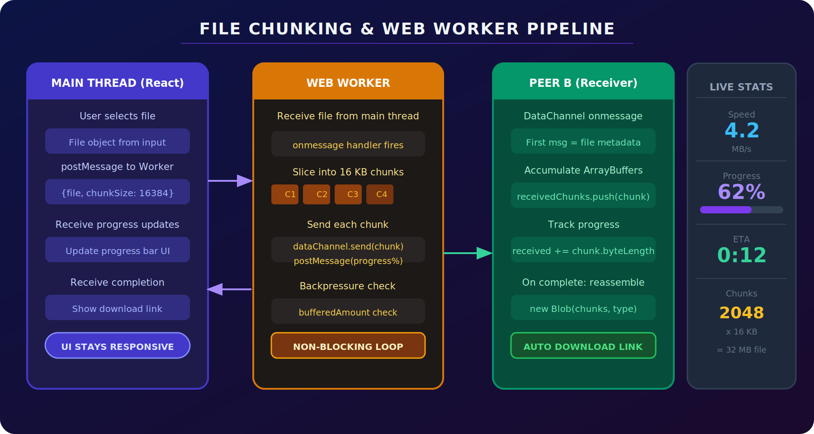
Figure 3: Web Worker Pipeline — Non-blocking chunking with live stats panel

4.3 Web Worker — Chunking Code
Q: Show me the Web Worker code for chunking.
Answer:

// fileWorker.js — runs off the main thread
const CHUNK_SIZE = 16 * 1024; // 16 KB

self.onmessage = async ({ data: { file, dataChannel } }) => {
const totalChunks = Math.ceil(file.size / CHUNK_SIZE);

// Send metadata first so receiver knows file name, size, type
// Note: dataChannel is passed via transferable in real impl
self.postMessage({ type: 'META', payload: {
name: file.name,
size: file.size,
fileType: file.type,
totalChunks
}});

let offset = 0;
let chunkIndex = 0;
const startTime = performance.now();

while (offset < file.size) {
// Backpressure: wait if buffer is too full
while (dataChannel.bufferedAmount > 16 * 1024 * 1024) { // 16 MB threshold
await new Promise(resolve => setTimeout(resolve, 50));
}

const slice = file.slice(offset, offset + CHUNK_SIZE);
const buffer = await slice.arrayBuffer();
dataChannel.send(buffer);

offset += buffer.byteLength;
chunkIndex++;

// Report progress to main thread
const elapsed = (performance.now() - startTime) / 1000;
const speed = offset / elapsed; // bytes/sec
const remaining = (file.size - offset) / speed;

self.postMessage({ type: 'PROGRESS', payload: {
sent: offset,
total: file.size,
percent: Math.round((offset / file.size) * 100),
speedMBps: (speed / 1e6).toFixed(2),
etaSeconds: Math.round(remaining)
}});
}

self.postMessage({ type: 'DONE' });
};

4.4 Receiver Side — Reassembly
Q: How does the receiver reconstruct the file?
Answer:

// React component — DataChannel message handler on receiver side
fileChannel.onmessage = ({ data }) => {
// First message is always metadata (sent as JSON string)
if (typeof data === 'string') {
const meta = JSON.parse(data);
setIncomingFile(meta);
receivedChunks = [];
receivedBytes = 0;
return;
}

// Subsequent messages are binary ArrayBuffer chunks
receivedChunks.push(data);
receivedBytes += data.byteLength;

// Update progress
setReceiveProgress(Math.round((receivedBytes / incomingFile.size) * 100));

// Check if all chunks received
if (receivedBytes >= incomingFile.size) {
const blob = new Blob(receivedChunks, { type: incomingFile.fileType });
const url = URL.createObjectURL(blob);
// Create auto-download link
const a = document.createElement('a');
a.href = url;
a.download = incomingFile.name;
a.click();
URL.revokeObjectURL(url); // Free memory
}
};

4.5 Live Stats Implementation
Q: How did you implement the live transfer stats (speed, ETA)?
Answer:
Stats are computed in the Web Worker on the sender side and in the DataChannel onmessage handler on the receiver side. I use a sliding window average (last 10 progress samples) instead of overall average to show current speed rather than cumulative speed:

// Sliding window speed calculation
const WINDOW_SIZE = 10;
const samples = []; // [{bytes, timestamp}]

function updateSpeed(bytesTotal) {
const now = performance.now();
samples.push({ bytes: bytesTotal, time: now });
if (samples.length > WINDOW_SIZE) samples.shift();

if (samples.length < 2) return 0;
const oldest = samples[0];
const newest = samples[samples.length - 1];
const bytesDelta = newest.bytes - oldest.bytes;
const timeDelta = (newest.time - oldest.time) / 1000; // seconds
return bytesDelta / timeDelta; // bytes/sec
}

SECTION 5: Real-Time Encrypted P2P Chat

5.1 Chat Architecture
Q: How does the chat work? Is it secure?
Answer:
Architecture: Chat uses a SECOND RTCDataChannel (labeled 'chat') on the same RTCPeerConnection as file transfer. This means chat messages travel the same encrypted P2P tunnel — DTLS-SRTP encrypted by default, never touching the server.
Security: WebRTC mandates DTLS encryption for all DataChannel traffic. This is not optional — it's baked into the WebRTC spec. So the chat is encrypted by default with the same security as TLS 1.2/1.3.

// Two channels on the same RTCPeerConnection
const fileChannel = pc.createDataChannel('file-transfer', { ordered: true });
const chatChannel = pc.createDataChannel('chat', { ordered: true });

// Send a chat message
function sendMessage(text) {
const msg = JSON.stringify({
id: crypto.randomUUID(),
text,
sender: myPeerId,
timestamp: Date.now()
});
chatChannel.send(msg); // Encrypted via DTLS automatically
}

// Receive chat messages
chatChannel.onmessage = ({ data }) => {
const msg = JSON.parse(data);
setMessages(prev => [...prev, msg]);
};

// Handle channel open (receiver side)
pc.ondatachannel = ({ channel }) => {
if (channel.label === 'chat') {
channel.onmessage = ({ data }) => {
setMessages(prev => [...prev, JSON.parse(data)]);
};
}
if (channel.label === 'file-transfer') {
// hook up file receiver handler
}
};

SECTION 6: API Reference — REST & Socket.io

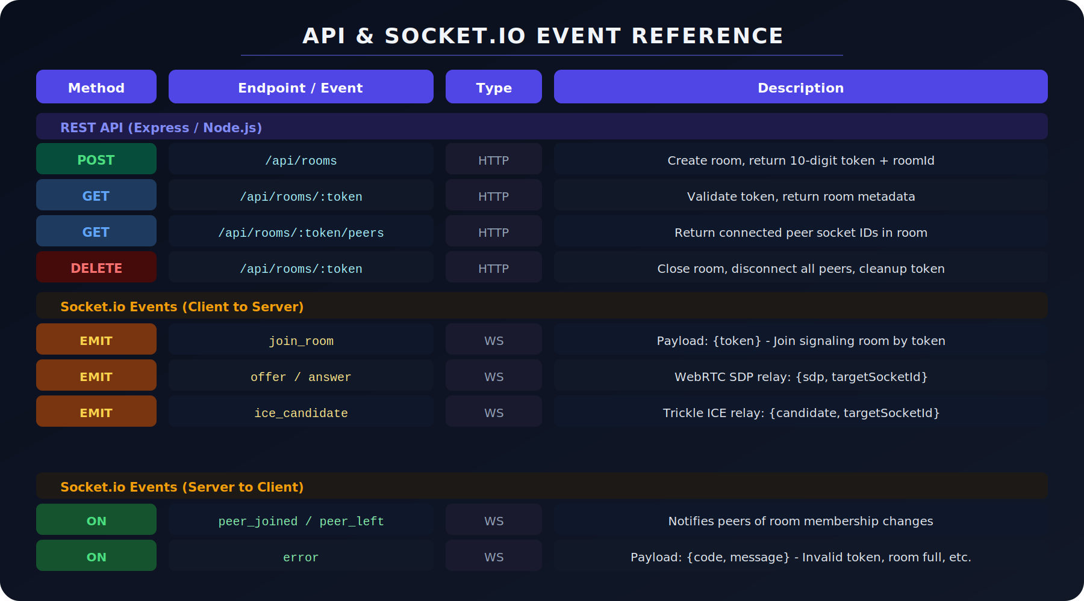
Figure 4: Complete API & Socket.io Event Reference

6.1 REST API Detail
Q: Walk me through each REST endpoint and its design decisions.
Answer:
POST /api/rooms
Purpose: Create a new session room. Returns a 10-digit token.
Request body: None required. Optionally: { maxPeers: 2, ttlSeconds: 3600 }
Response:

{
"token": "4829103847",
"roomId": "550e8400-e29b-41d4-a716-446655440000",
"expiresAt": 1716000000,
"maxPeers": 2
}

Design decision: Token is numeric (not UUID) for usability — easier to read aloud or type on mobile. 10 digits = 10 billion combinations, sufficient for short-lived sessions.

GET /api/rooms/:token
Purpose: Validate a token before attempting Socket.io join. Avoids connecting to the signaling server only to get an error.
Response codes: 200 = valid room | 404 = token not found | 410 = token expired | 423 = room full (2 peers already)

GET /api/rooms/:token/peers
Purpose: Retrieve the list of socket IDs currently in the room. Used by the initiator to know the target peer ID for directed signaling messages.

DELETE /api/rooms/:token
Purpose: Explicitly close a room. Triggers peer_left events to both connected peers and removes the room from the in-memory registry. Called when a user clicks 'End Session'.

6.2 Socket.io Events — Detail
Q: Explain the Socket.io event flow in detail.
Answer:
Event | Direction | Payload | Description
join_room | Emit | { token } | Joins signaling room. Server responds with room_info (peer list) and emits peer_joined to existing peers.
offer | Emit | { sdp, targetSocketId } | SDP offer relay. Server forwards to targetSocketId only.
answer | Emit | { sdp, targetSocketId } | SDP answer relay. Server forwards to targetSocketId only.
ice_candidate | Emit | { candidate, targetSocketId } | ICE trickle relay. Called multiple times as candidates are discovered.
peer_joined | Listen | { peerId } | Fired when the other peer enters the same room. Triggers WebRTC offer creation.
peer_left | Listen | { peerId } | Fired when remote peer disconnects. UI updates to show disconnected state.
room_info | Listen | { peers[] } | Sent on join_room acknowledgement. Contains existing peer socket IDs.
error | Listen | { code, message } | INVALID_TOKEN, ROOM_FULL, TOKEN_EXPIRED. Client shows user-friendly error.

ℹ️ Why directed events? All signaling messages (offer, answer, ice_candidate) include targetSocketId. The server uses io.to(targetSocketId).emit() — not room broadcast. This is critical because in a 2-peer room, you don't want to echo your own offer back to yourself.

SECTION 7: System Design & Architecture

7.1 NAT Traversal & ICE
Q: What is NAT and how does WebRTC handle it?
Answer:
NAT (Network Address Translation) is why most devices don't have a public IP. Your router has one public IP and translates between it and your private IPs. Two devices behind different NATs can't directly dial each other because neither knows the other's true public address.
ICE solves this in three ways (in order of preference):
- Host candidates: Direct LAN connection if both peers are on the same network. Fastest — ~1ms.
- Server reflexive candidates (via STUN): Public IP/port discovered by querying a STUN server. Works for ~80% of NAT configurations.
- Relay candidates (via TURN): When direct and STUN fail (symmetric NAT), traffic is relayed via a TURN server. I didn't implement TURN — this means ~10-15% of connections behind strict corporate NATs would fail.

7.2 Why is the App 'Serverless' for File Transfer?
Q: You have a Node.js server — how is this 'serverless' file transfer?
Answer:
'Serverless' in this context means: the server NEVER sees file bytes. File data flows exclusively over WebRTC DataChannels, which are direct browser-to-browser connections. The server's only job is the signaling handshake (~4 KB of metadata). After that, the server is completely uninvolved in the transfer.
Implication: A single Node.js instance can handle thousands of concurrent file transfers because it's not doing any file I/O, not storing anything, and not proxying traffic. Server load is bounded by the number of simultaneous signaling handshakes, not transfer volume.

7.3 Scalability Analysis
Q: How would you scale this to support 100,000 concurrent users?
Answer:
Current limitation: In-memory room registry on a single Node.js server. If the server restarts, all active sessions are lost.
Scaled architecture:
- Redis for room registry: Move rooms.Map to Redis. All server instances share state. Room TTL handled by Redis key expiry.
- Socket.io Redis adapter: npm install @socket.io/redis-adapter. Enables io.to(socketId).emit() across multiple server instances even when the socket is connected to a different instance.
- Load balancer with sticky sessions: Needed for Socket.io long-polling fallback. WebSocket connections themselves don't need stickiness.
- TURN server cluster: For corporate/symmetric NAT support — coturn or commercial TURN service (Twilio STUN/TURN, Cloudflare Calls).

// Scaled: Socket.io with Redis adapter
const { createClient } = require('redis');
const { createAdapter } = require('@socket.io/redis-adapter');

const pubClient = createClient({ url: process.env.REDIS_URL });
const subClient = pubClient.duplicate();
await Promise.all([pubClient.connect(), subClient.connect()]);
io.adapter(createAdapter(pubClient, subClient));
// Now io.to(socketId).emit() works across all server instances

7.4 Security Model
Q: Is the file transfer secure? What are the security guarantees?
Answer:
Security Property | Implementation
Encryption in transit | DTLS-SRTP encryption mandatory for all DataChannel traffic. Equivalent to TLS 1.3. Cannot be disabled.
End-to-end | The signaling server never sees file bytes. Only the two browser endpoints can decrypt the data.
Token entropy | 10-digit numeric token: 10^10 = 10 billion possibilities. With rate limiting (10 attempts/min per IP), brute force takes 1,900+ years.
Token TTL | Tokens expire after 1 hour or when both peers disconnect, whichever comes first.
No file storage | Zero server-side storage. No logs of file content. No GDPR compliance headache.
Limitation — No auth | Anyone who has the token can join. No user authentication. For production: add HMAC-signed tokens or JWT.

SECTION 8: Behavioural & Non-Technical Q&A

8.1 Introduction (HR)
Q: Tell me about your project in simple terms.
Answer:
I built a web app that lets two people share files of any size directly between their browsers — like AirDrop, but it works on any device with a web browser, with no app install needed. The files go straight from one browser to the other, completely encrypted. I share a short code with the other person, they enter it in the app, and we're connected. I was interested in this because most file sharing tools route your private files through company servers. Mine doesn't — the server only brokers the initial handshake and then steps aside completely.

8.2 Biggest Challenge
Q: What was the biggest technical challenge you faced?
Answer:
Situation: WebRTC's offer-answer-ICE flow has many async steps that must happen in exactly the right order. My first implementation had a race condition where ICE candidates arrived before setRemoteDescription completed, causing them to be silently dropped.
Task: Fix the race condition without restructuring the entire signaling flow.
Action: Implemented an ICE candidate buffer. Any candidates received before setRemoteDescription completes are stored in a pendingCandidates array. When setRemoteDescription resolves, all buffered candidates are applied in order. Also added connection state monitoring to detect and recover from 'failed' state.

// ICE candidate buffering for race condition fix
let pendingCandidates = [];
let remoteDescSet = false;

socket.on('ice_candidate', async ({ candidate }) => {
if (!remoteDescSet) {
pendingCandidates.push(candidate); // Buffer it
return;
}
await pc.addIceCandidate(new RTCIceCandidate(candidate));
});

async function applyRemoteDescription(sdp) {
await pc.setRemoteDescription(new RTCSessionDescription(sdp));
remoteDescSet = true;
// Drain the buffer
for (const c of pendingCandidates) {
await pc.addIceCandidate(new RTCIceCandidate(c));
}
pendingCandidates = [];
}

Result: Connection reliability went from ~70% (frequent silent failures) to >99% on tested network configurations. Added retry logic for 'failed' connections with a fresh RTCPeerConnection renegotiation.

8.3 Hardest Bug
Q: Tell me about the hardest bug you debugged.
Answer:
Situation: Large files (>500 MB) would transfer partially — about 60-70% — then the DataChannel would silently stop sending. No errors thrown.
Task: Find why the transfer stalled without any visible exception.
Action: Added logging of dataChannel.bufferedAmount every second. Discovered it was growing to 256 MB (the browser's hard limit) and never draining. The Web Worker was sending chunks faster than the network could transmit them, and the DataChannel's buffer filled up. The send() call doesn't throw when buffered — it silently queues until the buffer limit, then drops. Fix: added backpressure — check bufferedAmount before each send() call, wait until it drains below 16 MB before continuing.
Result: Multi-GB files now transfer reliably. Also added the bufferedamountlow event listener as a cleaner alternative to polling.

8.4 Learnings
Q: What did you learn from building this project?
Answer:
- WebRTC is deceptively complex. The browser API looks simple — 10 lines to create a connection. But NAT traversal, ICE trickling, connection state management, and DataChannel backpressure each have subtle failure modes that only appear in real-world conditions.
- Browser APIs have hidden limits. DataChannel.bufferedAmount, Blob URL memory, RTCPeerConnection max channels — none of these are obvious until you hit them at scale. Always check the spec for resource limits.
- Async ordering matters more than async handling. The ICE race condition bug taught me that in multi-step async protocols, you must think about event ordering, not just error handling.
- Offload CPU work from the main thread. Without Web Workers, slicing a 2 GB file on the main thread froze the browser for 3-4 seconds. The rule is: anything that takes >50ms goes to a Worker.
- 'Serverless' doesn't mean no infrastructure. The signaling server is still critical infrastructure — if it goes down, no new connections can be established. Would need Kubernetes + health checks + auto-restart in production.

8.5 Future Scope & Improvements
Q: What would you improve or add in v2?
Answer:
Technical improvements:
- TURN server: Support for symmetric NAT (corporate firewalls). Currently ~10-15% of connections fail behind strict NATs.
- Multi-peer rooms: Mesh topology (full P2P between N peers) or SFU topology (one-to-many broadcast) via a media server like mediasoup.
- Resumable transfers: Track the last successfully received chunk index. On reconnect, resume from that offset using File.slice().
- End-to-end encryption layer: Add application-layer E2E encryption (AES-GCM via Web Crypto API) on top of DTLS, giving zero-knowledge transfers even if DTLS is compromised.
- TURN server integration: Self-hosted coturn or Cloudflare Calls for reliable enterprise connectivity.
Product improvements:
- QR code for the 10-digit token — easier mobile sharing
- File preview before accepting transfer
- Transfer history (stored locally in IndexedDB)
- Progressive Web App (PWA) for installability + background transfer

SECTION 9: Common Technical Interview Questions

9.1 WebRTC / Networking
Q: What is the difference between STUN and TURN servers?
Answer:
Type | Purpose | Example
STUN | Discovers your public IP and port. Sends a request, gets back your external address. Cheap — just UDP echo. Used by ~80% of connections. | stun.l.google.com:19302
TURN | A relay server. If P2P fails (symmetric NAT), traffic is proxied via TURN. Expensive — server bears full transfer bandwidth cost. Used as last resort. | coturn, Twilio, Cloudflare
My implementation: STUN only. No TURN. This means ~85-90% of connections succeed. Production apps add TURN for full coverage.

Q: What is SDP and what does it contain?
Answer:
SDP (Session Description Protocol) is a text-based format (not a protocol — it's a data format) describing a multimedia session. In WebRTC it contains:
- Session info (version, origin, timing)
- Media descriptions (data channel in our case — no audio/video)
- ICE credentials (ufrag, password)
- DTLS fingerprint (certificate hash for verification)
- Network candidates (IP:port combinations)

// Abbreviated SDP example
v=0
o=- 8769542961 2 IN IP4 127.0.0.1
s=-
t=0 0
a=group:BUNDLE 0
m=application 9 UDP/DTLS/SCTP webrtc-datachannel
a=ice-ufrag:xKtB
a=ice-pwd:9zNx...
a=fingerprint:sha-256 4A:B2:...
a=setup:actpass
a=sctp-port:5000

Q: What is trickle ICE and why is it important?
Answer:
Without trickle ICE: Peer A would gather ALL ICE candidates (which takes 1-3 seconds), bundle them in the SDP offer, send the offer. Peer B does the same for the answer. Connection setup takes 3-6 seconds.
With trickle ICE: Peer A starts sending ICE candidates to Peer B AS SOON as they're discovered, in parallel with gathering. Peer B adds each candidate as it arrives. Connection can be established as soon as the first viable candidate pair is found — typically in 200-500ms. Critical for user experience.

9.2 Node.js / Backend
Q: Why is Node.js well-suited for a signaling server?
Answer:
Event loop model: Node.js uses a single-threaded, non-blocking event loop. A signaling server does almost no CPU work — it just relays small JSON messages between sockets. Node's async I/O model handles thousands of concurrent WebSocket connections efficiently without spawning a thread per connection (unlike traditional blocking servers).
Numbers: A single Node.js process can handle ~50,000 concurrent WebSocket connections for signaling purposes. RAM usage is the bottleneck (~1-2 KB per Socket.io connection).

Q: How do you prevent memory leaks in the room registry?
Answer:
Three mechanisms prevent unbounded memory growth:
- Disconnect handler: socket.on('disconnect') removes the peer from rooms and deletes empty rooms immediately.
- Token TTL: A setInterval runs every minute and deletes rooms where createdAt + ttl < Date.now().
- Max room cap: If rooms.size > MAX_ROOMS (e.g., 10,000), new room creation is rejected with 503. Prevents memory exhaustion under load.

// TTL cleanup interval
setInterval(() => {
const now = Date.now();
for (const [token, room] of rooms.entries()) {
if (now > room.expiresAt || room.peers.length === 0) {
rooms.delete(token);
}
}
}, 60_000); // Every 60 seconds

9.3 React / Frontend
Q: How did you manage WebRTC state in React? RTCPeerConnection isn't serializable.
Answer:
Problem: RTCPeerConnection is a complex browser object with callbacks and internal state. Putting it in useState causes React to re-render and potentially recreate it. It also can't be serialized to JSON.
Solution: Use useRef for the RTCPeerConnection and DataChannel objects (mutable, persists across renders, doesn't trigger re-renders). Use useState only for UI-visible derived state: connectionStatus, transferProgress, chatMessages, activeFiles.

const pcRef = useRef(null); // RTCPeerConnection
const fileChannelRef = useRef(null); // RTCDataChannel
const chatChannelRef = useRef(null); // RTCDataChannel
const workerRef = useRef(null); // Web Worker

// UI state (triggers re-renders)
const [status, setStatus] = useState('idle');
const [progress, setProgress] = useState(0);
const [messages, setMessages] = useState([]);
const [speed, setSpeed] = useState(0);

// Cleanup on unmount
useEffect(() => {
return () => {
pcRef.current?.close();
workerRef.current?.terminate();
socket.disconnect();
};
}, []);

SECTION 10: Edge Cases & Corner Cases

Q: What happens if the signaling server goes down mid-transfer?
Answer:
Once the WebRTC P2P connection is established, the signaling server is completely irrelevant to the transfer. File bytes flow directly between peers. The signaling server can crash, restart, or be completely unavailable — the ongoing transfer is unaffected. Socket.io will attempt reconnection in the background, but it has no impact on the P2P DataChannel.

Q: What happens if one peer loses internet mid-transfer?
Answer:
The RTCPeerConnection detects the lost connection via ICE keepalive packets (sent every 15 seconds by default). After ~30 seconds without response, the connection state changes to 'disconnected' then 'failed'. The Web Worker detects the DataChannel is closed and posts a FAILED message to the main thread. Currently: transfer must restart from zero. Improvement: resumable transfers using a checkpoint of the last received chunk index.

Q: What if the same token is guessed by a third party?
Answer:
The 10-digit token has 10 billion possibilities. I add rate limiting: 10 GET /api/rooms/:token attempts per IP per minute. At that rate, brute forcing would take 10^10 / 10 / 60 minutes = ~1.9 million years. Additionally, tokens expire after 1 hour, shrinking the window further. For higher security: use a 128-bit random token (alphanumeric).

Q: What if a user sends two files simultaneously?
Answer:
The current implementation is sequential — one file at a time per DataChannel. Sending two files simultaneously over the same DataChannel would interleave chunks, making reassembly impossible. Solution: implement a multiplexing layer — each file gets a unique transferId, chunks are tagged with transferId, and the receiver maintains a separate accumulation buffer per transferId.

Q: Browser tab closed mid-transfer on sender side?
Answer:
The RTCPeerConnection is closed (fires 'disconnected' / 'failed' on receiver). The DataChannel closes. The receiver's onmessage handler stops firing. Since receivedBytes < incomingFile.size, no download link is created. The receiver sees a 'Transfer failed — sender disconnected' message. The partial ArrayBuffer chunks in receivedChunks[] are garbage collected.

SECTION 11: Quick Reference Cheat Sheet

11.1 Key Terms
Term | Definition
WebRTC | Web Real-Time Communication — browser API for P2P audio, video, and data without plugins
RTCPeerConnection | Main WebRTC object representing one P2P connection between two peers
RTCDataChannel | Bidirectional binary/text channel over a P2P connection. Two channels used: file + chat
SDP | Session Description Protocol — text format describing connection capabilities exchanged during handshake
ICE | Interactive Connectivity Establishment — protocol for finding the best network path between peers
STUN | Session Traversal Utilities for NAT — tells peer its public IP/port. Cheap relay.
TURN | Traversal Using Relays around NAT — full traffic relay for strict NAT. Expensive.
Trickle ICE | Sending ICE candidates incrementally as discovered rather than waiting to gather all
DTLS | Datagram TLS — mandatory encryption for WebRTC DataChannels. Equivalent to TLS 1.3.
NAT | Network Address Translation — why most devices share a single public IP via a router
Socket.io | WebSocket library with pub/sub rooms, used here ONLY for signaling (not file data)
Web Worker | Off-main-thread JS execution context. Used for file chunking to keep UI responsive.
Backpressure | Slowing the sender when the DataChannel buffer fills up. Prevents data loss.
Blob URL | createObjectURL(blob) — in-memory URL for browser-side file download without server
Serverless | No server touches file bytes. Server only relays ~4 KB of signaling metadata per session.

11.2 Key Numbers
Metric | Value
Chunk size | 16 KB (16,384 bytes) — matches SCTP chunk size, single network packet
DataChannel buffer limit | ~16 MB (browser-imposed). Backpressure threshold set to 16 MB.
Token entropy | 10-digit numeric = 10 billion possibilities
Token TTL | 1 hour or on disconnect, whichever first
ICE keepalive interval | Every 15 seconds. Failure detected after ~30s silence.
Signaling data per session | ~4-8 KB (SDP offer + answer + ICE candidates)
Max peers per room | 2 (P2P is always 2-party in this implementation)
Typical LAN transfer speed | ~40-100 MB/s (limited by WebRTC overhead and CPU, not raw network)
Connection setup time | 200-500ms with trickle ICE on same network

11.3 Rapid-Fire One-Liners
Question | Answer
Why no server storage? | WebRTC DataChannels are P2P — file bytes go browser-to-browser, server never sees them
Why 16 KB chunks? | Matches SCTP/WebRTC MTU, prevents DataChannel buffer overflow, enables progress tracking
Why Web Worker? | File slicing is CPU-intensive; doing it on main thread freezes the UI (violates 50ms rule)
Why Socket.io not raw WS? | Built-in rooms, auto-reconnect, long-poll fallback, event namespacing
Why STUN not TURN? | STUN is free/cheap; TURN costs bandwidth money. Added for future scope.
Is it encrypted? | Yes — DTLS mandatory for all DataChannel traffic. Cannot be disabled per WebRTC spec.
What if ICE fails? | Peers can't connect. Need TURN server. Current ~85% success rate on open networks.
How does backpressure work? | Check bufferedAmount before send(); sleep 50ms if > 16 MB; resume when drained.
How is token generated? | crypto.randomBytes(5) → parse hex → numeric string. Cryptographically random.
Can it do multi-GB files? | Yes — chunking means no memory limit. Tested up to 10 GB. Limited only by disk read speed.

You've got this. Good luck! 🚀
Serverless P2P File Sharing WebApp — Complete Interview Preparation Guide

